**ECO 304L Exam 1 Spring 2024**

**Version: AC MASTER CANVAS**

**Last Name: __________________**

**First Name: __________________**

**UT ID: __________________**

**Directions:** There are 40 questions on this exam. Each question is worth the same (1 point). You also **MUST SKIP 3** questions, which are automatically counted correct. For each multiple-choice question, select the best response. For each short answer question, you can earn 1/2 credit if your answer is incorrect, but you explain your reasoning/show your work. This is a closed book, closed notes exam. You may use a physical calculator but may not use a cell phone or any other electronic device during the exam. Make sure you write your full name and UT ID above. Hand in your exam and show your student ID to the TA when turning in your exam. Good luck!

**\*\*\*Write the word SKIP next to three questions\*\*\***

**Multiple-Choice Answers: Short Answers:**

**1. ___A_____ 17. ___D_____ 33. S = $90 million________**

**2. ___D_____ 18. ___A_____ I = $150 million ________**

**3. ___B_____ 19. ___B_____ 34. _____5%**

**4. ___A_____ 20. ___C_____ 35. $19,000 ________**

**5. ___C_____ 21. ___D_____ 36. _____6.2%**

**6. ___D_____ 22. ___B_____ 37. _____0%**

**7. ___A_____ 23. ___C_____ 38. _____70.58%**

**8. ___C_____ 24. ___A_____ 39. $4.95________**

**9. ___C_____ 25. ___A_____ 40. _____7%**

**10. __A______ 26. ___B_____**

**11. __B______ 27. ___B_____**

**12. __A______ 28. ___A_____**

**13. __D______ 29. ___C_____**

**14. __B______ 30. ___C_____**

**15. __C______ 31. ___B_____**

**16. __A______ 32. ___B_____**

**For Graders**

**Correct SA: ____ + Partial Credit: ____ x 1/2 ____ = Total SA Points: ____**

**TOTAL POINTS: MC: _____ + SA: _____ + 3 SKIPS = /40**

**1. According to the syllabus, if you complete exams 1-3, then the final exam is:**

**A) optional.**

B) mandatory.

**2. Which of the following is a service?**

A) A visit to your local lake.

B) A trip to the store to buy some socks.

C) Lunch at a friend’s home.

**D) A visit to your dentist.**

**3. To evaluate the change in average living standards over time, it is best to use real GDP.**

A) True.

**B) False.**

**4. Country A has a real gross domestic product (GDP) of $750,000 and a population of 250. Country B has a real GDP of $500,000 and a population of 150. Which of the following is true?**

**A) The value of real per capita GDP is higher in Country B.**

B) The value of total output is higher in Country B.

C) The value of total income is higher in Country B.

D) The value of real per capita GDP is higher in Country A.

**5. An engine is used to produce a car that is sold to consumers. The engine is ________ good and its value ________ counted in gross domestic product (GDP). The car is ________ good and its value ________ counted in GDP.**

A) an intermediate; is; an intermediate; is

B) an intermediate; is; a final; is not

**C) an intermediate; is not; a final; is**

D) a final; is; an intermediate; is not

**6. *Consider the following data that give the quantity produced and unit price for three goods across two years to answer the following question. Assume that goods A, B and C are the economy’s entire output and that the base year is 2022.***

|  |  |  |  |  |
| --- | --- | --- | --- | --- |
| **Good** | 2022 Price | 2022 Quantity | 2023 Price | 2023 Quantity |
| A | $1 | 500 | $2 | 600 |
| B | $2 | 700 | $3 | 800 |
| C | $10 | 200 | $10 | 300 |

**What was the growth rate of real gross domestic product (GDP) between 2022 and 2023?**

A) 28.45%

B) 47.92%

C) 62.01%

**D) 33.33%**

**7. A company sells 1,000 boxes of nails, yet it produced only 925 boxes of nails during the year. Which of the following is true?**

**A) Inventory investment must be negative.**

B) Inventory investment must be positive.

C) The price of nails must have gone up.

D) The firm must have acquired the extra 75 bags from another company.

**8. *Consider an economy that only produces three goods: apricots, berries and carrots.***

|  |  |  |  |  |  |  |
| --- | --- | --- | --- | --- | --- | --- |
| **Year** | **Price of apricots (lb)** | **Quantity of apricots (lb)** | **Price of berries (lb)** | **Quantity of berries (lb)** | **Price of carrots (lb)** | **Quantity of carrots (lb)** |
| 2021 | $1 | 10 | $1.5 | 10 | $2 | 11 |
| 2022 | $2 | 12 | $2 | 14 | $3 | 15 |
| 2023 | $3 | 13 | $3 | 12 | $2 | 10 |

**The GDP deflator in 2021 is ___; the GDP deflator in 2022 is ____ and the GDP deflator in 2023 is ___. (Year 2021 is the base year).**

A) 100; 136.87; 181.54

B) 100; 165.77; 191.25

**C) 100; 153.96; 186.27**

D) 100; 147.86; 183.09

**9. Due to the rising cost of a college education, a greater percentage of students have part-time jobs in comparison to past years. All else being equal, this decrease in the number of full-time nonworking students can be expected to ________ the labor force participation rate and ________ the unemployment rate.**

A) increase; have no effect on

B) increase; increase

**C) increase; decrease**

D) have no effect on; have no effect on

**10. *Refer to the following scenario to answer the next question.***

***A government worker surveys a number of households and comes up with the following information: there were a total of 200 people in the households, 25 of the people were children under 16, 10 of the people were retired but still capable of working, 100 people had full-time jobs, 17 had part-time jobs, 10 were stay-at-home parents, 20 were full-time students over the age of 16, 5 were disabled people who could not work, 8 people had no job but were looking for jobs, and there were 5 people who wanted a job but were not looking for a job.***

**According to the information in the survey, the unemployment rate is:**

**A) 6.4%**.

B) 5.2%.

C) 7.3%.

D) 4.8%.

**11. All economies should strive for an unemployment rate of zero.**

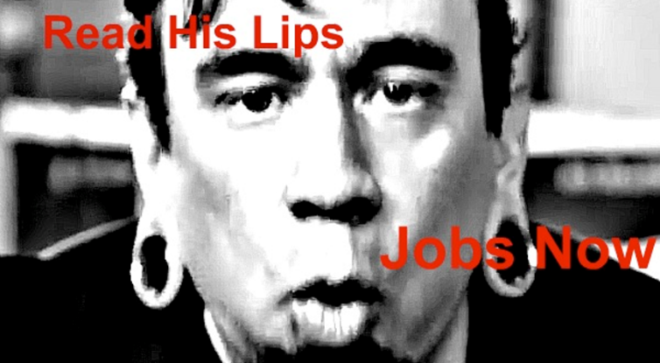

A) True.

**B) False.**

**12. Holding all else constant, if people who are currently unemployed decide to retire, you will see:**

**A) a decrease in the labor force participation rate.**

B) an increase in the unemployment rate.

C) an increase in the labor force participation rate.

D) no effect on the unemployment rate.

**13. When actual unemployment is less than its natural rate:**

A) the economy is producing below its long-run capabilities.

B) the economy is producing low levels of real GDP.

C) natural resources are employed at levels that are constant.

**D) resources are employed at levels that are not sustainable in the long run.**

**14. Mary and Armando just got married. Armando recently graduated and received a master’s degree in finance. He is currently searching for a job that matches his new skill set and interest. However, Mary just lost her job as a bookkeeper because she was replaced by a very efficient software program. In this example, Armando is ________ unemployed and Mary is ________ unemployed.**

A) creatively; cyclically

**B) frictionally; structurally**

C) frictionally; cyclically

D) structurally; creatively

**15. Which of the following conditions might cause the unemployment rate to be less than the natural rate of unemployment?**

A) Demand for products starts to decrease, so firms keep their factories open for additional hours of production to make up the difference.

B) Demand for products is so high that firms raise their prices to take advantage of extra sales.

**C) Demand for products is so high that firms keep their factories open for additional hours of production and hire more workers.**

D) The economy enters a recession, so firms start to produce more to help boost the economy.

**16. If the labor force participation rate increases, which of the following is a likely cause?**

**A) Homemakers began looking for work in large numbers, but the size of the relevant adult population did not change.**

B) The size of the labor force decreased, but the size of the relevant adult population did not change.

C) The number of marginally attached workers increased, but the size of the relevant adult population did not change.

D) Baby boomers started retiring in large numbers, but the size of the relevant adult population did not change.

**17. *Consider a simple economy that produces only three products: donuts, eggs, and flour.***

|  |  |  |  |  |
| --- | --- | --- | --- | --- |
| **Product** | **Quantity** | **Base Year**  **Price (2009)** | **Price (2022)** | **Price (2023)** |
| Donuts | 5 | $1 | $2 | $3 |
| Eggs | 8 | $5 | $6 | $8 |
| Flour | 10 | $2 | $5 | $7 |

**Using the information in the table above, the inflation rate for 2023 is ____.**

A) 45.67%

B) 43.97%

C) 56.21%

**D) 37.96%**

**18. Suppose a jar of mustard cost $0.75 in 1970 and $3.20 in 2023. If the price index was 38 in 1970 and 225 in 2023, we could accurately say that:**

**A) the price of mustard has increased less rapidly than inflation.**B) the price of mustard has increased more rapidly than inflation.  
C) the price of mustard has increased at the same rate as inflation.  
D) the nominal price of mustard has fallen.

**19. A country’s consumer price index (CPI) was 160 last year, and this year it is 170. Inflation is 10% this year.**

A) True.

**B) False.**

**20. If inflation is estimated by the consumer price index to be higher than it actually is, who is liable to be hurt by this error?**

A) Workers whose negotiated union wages includes an inflation adjustment.

B) People whose pensions are adjusted for inflation.

**C) Firms that adjust worker salaries to keep pace with inflation.**

D) Entrepreneurs who borrow from banks at a fixed interest rate.

**21. If tacos become more expensive and consumers switch their purchases away from tacos but the consumer price index still assumes they buy the same amount, then:**

A) the CPI will reflect downward bias.

B) consumers will experience money illusion.

C) consumers will experience a price confusion problem.

**D) the CPI will reflect upward bias.**

**22. Suppose that Bruce gets a 4% raise this year, but prices have also risen by 4%. Bruce feels richer due to his raise and attempts to change his spending habits. Bruce is suffering from:**

A) irrational exuberance.

**B) money illusion.**

C) macroeconomics.

D) inflation pricing.

**23. If nominal income increases, then real income:**

A) increases if the percentage increase in price index rises by more than the percentage change in nominal income.

B) increases if you buy only the goods included in the consumer price index (CPI) and the majority of those goods get cheaper.

**C) increases if the price index falls.**

D) decreases.

**24. Typically, if real wages fall, the quantity demanded of labor rises. If workers agree to 5% wage increases for a 4-year period and inflation is less than 5%, then based on this information alone:**

**A) the quantity demanded of labor will decrease because real wages rose.**B) workers will have higher real wages because they get paid more.  
C) the quantity demanded of labor will increase because real wages fell.  
D) the demand, but not the quantity demand, for labor will fall.

**25. Which of the following reflects an accurate economic chain of events?**

**A) Savings finances investment, which allows the economy to grow as a result of a larger capital stock.**

B) Investment finances savings, which causes the economy to shrink.

C) Savings finances future consumption, which allows future production to increase from a larger capital stock.

D) Investment finances future consumption, which allows incomes—and thus savings—to grow.

**26. George is part of a small group of friends that has formed a corporation to build a cafe. The group will likely need to borrow funds. From this information we can tell that George and his friends:**

A) contribute to the supply curve in the market for loanable funds.

**B) contribute to the demand curve in the market for loanable funds.**

C) pay a low rate of interest because they are a small firm.

D) pay a high rate of interest because their product is in demand.

**27. Higher interest rates will shift the demand curve for loanable funds.**

A) True.

**B) False.**

**28. Why does increased business confidence shift the demand curve for loanable funds?**

**A) Higher business confidence means firms believe they will get a higher return on their investments, so they are incentivised to borrow more to invest.**

B) Higher business confidence means firms believe they will get a higher return on their investments, so they are incentivised to save more.

C) Higher business confidence means firms believe they will get a higher return on their investments, so they are incentivised to loan money to other firms.

D) Higher business confidence does not shift the demand curve for loanable funds.

**29. A marketing campaign successfully popularizes “Cyber Monday,” the Monday after Thanksgiving, as a day for people to start their online Christmas shopping instead of waiting until a few weeks before Christmas. The campaign has successfully**

A) caused people to increase their consumption smoothing.

B) caused people to reduce their time preferences.

**C) caused people to increase their time preferences.**

D) equalized the real and nominal rates of interest.

**30. Investors become more confident about the future while there is an increase in foreign savings in the United States. As a result, this would cause the:**

A) equilibrium quantity of loanable funds to decrease and the equilibrium interest rate to increase.

B) equilibrium quantity of loanable funds to increase and the equilibrium interest rate to decrease.

**C) equilibrium quantity of loanable funds to increase but the effect on the equilibrium interest rate would be uncertain.**

D) equilibrium interest rate to decrease but the new equilibrium quantity of loanable funds would be uncertain.

**31. Anita is in no hurry to upgrade her phone. “This one will do just fine for another year,” she tells people. We can say that, for electronics, Anita:**

A) has a high time preference.

**B) has a low time preference.**

C) is likely a demander of loanable funds.

D) prefers to borrow at the nominal rate rather than the real rate of interest, if inflation is positive.

**32. Which combination of events will always cause the equilibrium interest rate to fall and the equilibrium quantity of loanable funds (both borrowed and lent) to rise?**

A) Firms are more pessimistic, and governments run fewer deficits.

**B) More individuals are middle-aged, and wealth increases.**

C) A baby boom begins, and investor confidence rises.

D) People have higher time preferences, and governments run larger deficits.

**Enter your answers for the short answer section on the Answer (front) page.**

**33. Refer to the following graph to answer the following question.**

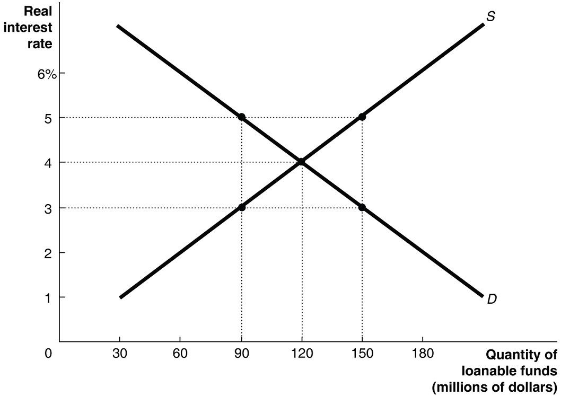

**If the real interest rate falls to 3%, what happens to the level of savings and investment?**

**Answer:** Savings fall to $90 million; investment rises to $150 million.

**34. You borrow $40,000 today at a rate of 7%. Today, inflation instantly drops to 2% and stays that way for the duration of your loan. Based on the above information, *ceteris paribus* (all else equal), today the real rate of interest on your loan is:**

**Answer:** 5%.

The real rate of interest = nominal rate – inflation or 7% - 2% = 5%.

**35. Farmer Ashley produces oranges. She sells half of her inventory to people at her roadside stand for $3,000 and sells the other half to Tropical Juice Co. for $8,000. Tropical Juice Co. uses the oranges to make orange juice, which it sells to consumers for $16,000. The impact of these transactions on gross domestic product (GDP) is ________.**

**Answer:** $19,000

Only the market value of final goods and services is counted in GDP.

Inventory sold at roadside stand: $3,000 (final good counted).

The inventory sold to Tropical Juice Co is an intermediate good, which is not counted. The orange juice sold to customers: $16,000 (final good counted).

**$3,000 + $16,000 = $19,000**

**36. *Consider the following data, where gross domestic product (GDP) values are measured in millions of dollars, to answer the following question.***

|  |  |  |  |
| --- | --- | --- | --- |
| **Year** | Nominal GDP | Real GDP | GDP Deflator |
| 2020 | ____ | $650 | 100.0 |
| 2021 | $700 | ____ | 103.7 |
| 2022 | $775 | $725 | ____ |
| 2023 | $847 | ____ | 110.0 |
|  |  | | |

**What was the growth rate of real gross domestic product (GDP) from 2022 to 2023?**

**Answer:** 6.2%

Real GDP in 2023 is ($847/110.0) x 100 = 770

$770 - $725 x 100 = 6.2%

$725

**37. *Consider a country with 100 million work-eligible residents, a labor force of 80 million, and 5 million unemployed. Suppose that 15 million jobs are now created, attracting 10 million new people into the labor force. Assume that everyone who is in the labor force can find a job if there is a job available.***

**According to this information, the new unemployment rate is ______.**

**Answer:** 0%.

Assuming that all new jobs gets filled, with 15 million new jobs created, 10 million are filled by people who were previously outside the labor force, and 5 million are filled by people who were previously unemployed inside the labor force. New unemployment is 5 million – 5 million = 0

**38. *Refer to the following scenario to answer the next question. A government worker surveys a number of households and comes up with the following information: there were a total of 200 people in the households, 25 of the people were children under 16, 10 of the people were retired but still capable of working, 95 people had full-time jobs, 15 had part-time jobs, 10 were stay-at-home parents, 20 were full-time students over the age of 16, 5 were disabled people who could not work, 10 people had no job but were looking for jobs, and there were 10 people who wanted a job but were not looking for a job.***

**According to this information, the labor-force participation rate is ______.**

**Answer:**  70.58%

Labor Force = 95 (full-time jobs) + 15 (part-time jobs) + 10 (unemployed) = 120

Work Eligible Population = 200 people – 25 children – 5 disabled = 170

120 x 100 = 70.58%

170

**39. A packet of Oreo cookies cost $0.32 in 1922. If the consumer price index (CPI) in 1922 was 17 and the current CPI is 263, then the inflation-adjusted price of Oreo cookies is _____:**

**Answer:** $4.95

Price in today’s dollars = price in earlier time x (CPI today / CPI past)

Price in today’s dollars = $0.32 x (263 / 17) = $4.95

**40. Suppose the real gross domestic product (GDP) grows by 2% and inflation is equal to 5%, but there is no change in the velocity of money. Based on the equation of exchange, by how much does the quantity of money change?**

**Answer:** 7%

%ΔM + %ΔV ≈ %ΔP + %ΔY

%ΔM + 0% = 5% + 2%

%ΔM= 7%